STEPS:

TASK 0:

The topology and connecting to the proactive controller

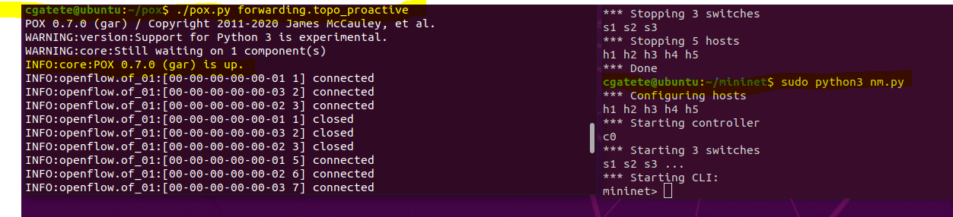

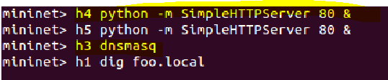

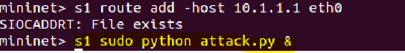

The python code used for topology making in mininet:

#/usr/bin/Python

from mininet.net import Mininet

from mininet.node import Controller, RemoteController, Node

from mininet.cli import CLI

from mininet.log import setLogLevel, info

from mininet.link import Link, Intf

def aggNet():

CONTROLLER_IP='127.0.0.1'

net = Mininet( topo=None,

build=False)

net.addController( 'c0',

controller=RemoteController,

ip=CONTROLLER_IP,

port=6633)

h1 = net.addHost( 'h1', ip='0.0.0.0' )

h2 = net.addHost( 'h2', ip='0.0.0.0' )

**Steps to run a proactive controlled circuit**

run pox controller:

cd pox

./pox.py forwarding.topo_proactive

Open another terminal:

Cd mininet

sudo python3 nm.py

observe if the remote controller pox is connected to the network topology

ATTACK

domain-neededbogus-privno-resolvserver=8.8.8.8server=8.8.4.4local=/mydomain.org/listen-address=::1,127.0.0.1,192.168.1.10expand-hostsdomain=mydomain.orgdhcp-range=192.168.1.100,192.168.1.200,24hdhcp-option=option:router,192.168.1.1dhcp-authoritativedhcp-leasefile=/var/lib/dnsmasq/dnsmasq.leasesInstall dnsmasqsudo dnf install dnsmasq2. Start the Dnsmasq servicesudo systemctl enable --now dnsmasq3. We are making a backup of the required filesudo cp /etc/dnsmasq.conf /etc/dnsmasq.conf.orig4. We edit the config filedomain-neededbogus-privno-resolvserver=10.3.1.1local=/foo.local/listen-address=::1,127.0.0.1,192.168.1.10expand-hostsdomain=mydomain.orgdhcp-range=192.168.1.100,192.168.1.200,24hdhcp-option=option:router,192.168.1.1

dhcp-authoritative

dhcp-leasefile=/var/lib/dnsmasq/dnsmasq. leases

server=10.3.1.1